Waterproof Action Camera Drone

In the world of filmmaking, Drones have opened a world of perspectives and camera angles. In recent years, the explosion in the availability of affordable drones has made it possible for anyone to take stunning aerial shots. Aspiring filmmakers, as well as seasoned directors, have begun exploring the endless creative possibilities offered by drones.
Despite all their advantages, most modern Drones suffer from one major shortcoming- they are extremely vulnerable to water damage. Most drones have a porous outer shell allowing water to seep in and damage the internal circuitry.
Due to this fatal flaw, most drones lose their operational capabilities during heavy rains and thunderstorms.
This waterproof action camera drone aims to tackle the vulnerability of conventional drones. Boasting a range of up to a kilometre, this drone is suitable for scouting, as well as shooting. Moreover, this drone can effortlessly carry a payload of up to 500 grams, allowing it to support all kinds of action cameras. Its waterproof body makes sure water remains away from its internal mechanism and circuitry.
Thus, allowing the drone to remain operational and letting you shoot stunning and scenic footage even in the pouring rain.

Features of Waterproof Action Camera Drone:

- Payload limit of 500 grams allows you to mount even the heaviest action camera.
- Waterproof body allows it to remain operational even in heavy rains and thunderstorms.
- Operational range of 1 kilometre makes it ideal for scenic outdoor shoots.
- Along with making it easy for transport, this drone’s Compact design allows it to take off from the palm of your hand.

Components:
- Drone Chassis
- 4 X Brushless Motors
- 4 X Propellers
- Action Camera Mount
- Charge Controllers
- Waterproof casing
- Flight Controller
- RC Remote
- Controller Circuitry
- Battery
- Motor Shafts
- Mounts & Couplings
- Screws & Bolts
- Supporting Frame

Applications:
- Extensive operational range allows scouting of new areas.
- Waterproof design allows it to shoot even in heavy rains.

Advantages:
- Waterproof design allows all weather operation.
- Compact design makes it easy to transport and fly.
- Broad range of operation makes it ideal for recce as well as shooting.
- Can support even the heaviest action camera.

Disadvantages:
- Not entirely autonomous, requires human operators.
Block Diagram:

Front View
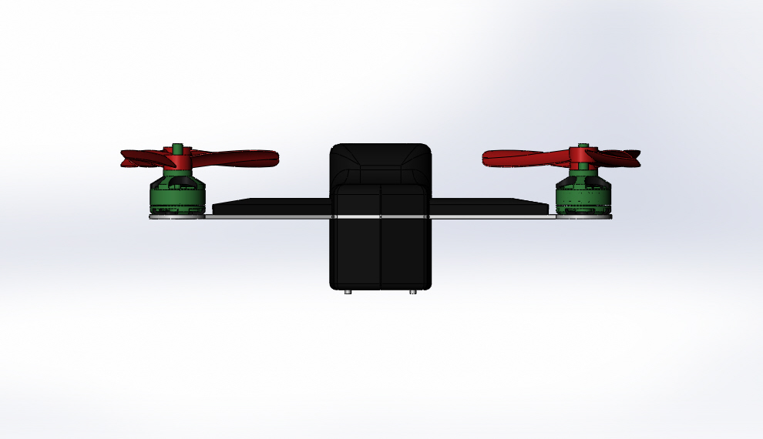

Side View
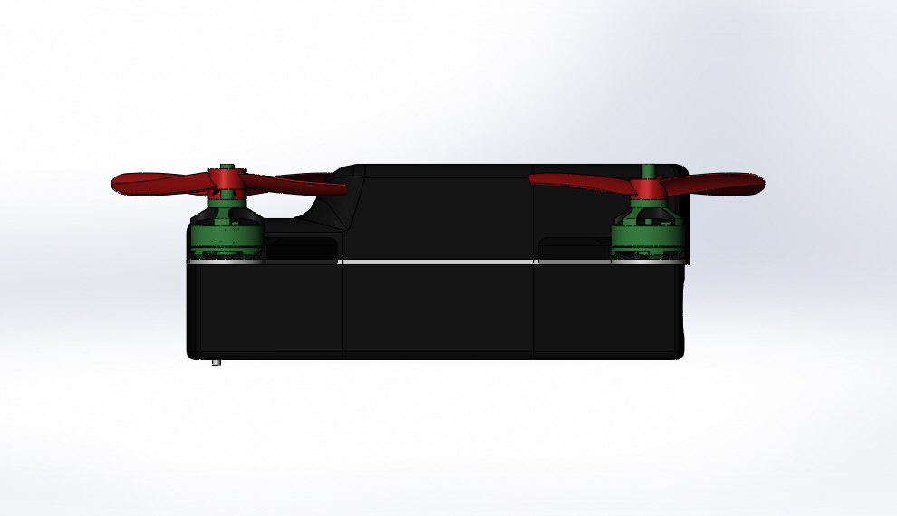

3D View

